M03: Assignment Case Study Chapter 5
- What type of site organization is used for the Pacific Trails Resort website? Is it the most appropriate organization for the site? Why or why not?
Pacific Trails Resort uses a hierarchical organization. I believe that it is the most appropriate organization for that site because it lets viewers check the pages in whatever order they want, which linear organization doesn’t do. Meanwhile, random organization will usually hide some pages behind others, which again does not provide access to everything to everyone to explore as they wish.
- Cite three design practices that have been well implemented. Cite three design practices that could be implemented in a better way. How else would you improve the website?
Well done stuff: first, paragraphs are not long. They’re short and to the point, which makes the text easy to follow. Second, the website’s organizational structure (hierarchical) is very well suited for the site’s purpose: entice customers to reserve a yurt to enjoy nature. Third, the website’s text is easy to see, due to very clearly contrasting colors.
Stuff that needs improvement: first, there are no descriptions for any pictures, so some should be added. Second, the images at the top of the screen are stretched – they could use better scaling for different screen sizes. Third, the nav bar is placed on the top of the screen, which is great for mobile, but is not the best use of space on PC due to how the rest of the page is laid out.
Other ideas for improvement: The pages are mostly empty when viewed on my laptop screen. They could use some filling up – maybe with more pictures.
- Can you try to organize your pages using linear or random organization? Please include your summary with either linear or random organization. Also, compare and contrast with which organization type was best fitted and which one was the most ill suited?
I think that if I’m going to change the Pacific Trails Resort site structure, I might try a random organization. The diagram below shows what I think would make a logical way people would regularly use the site.
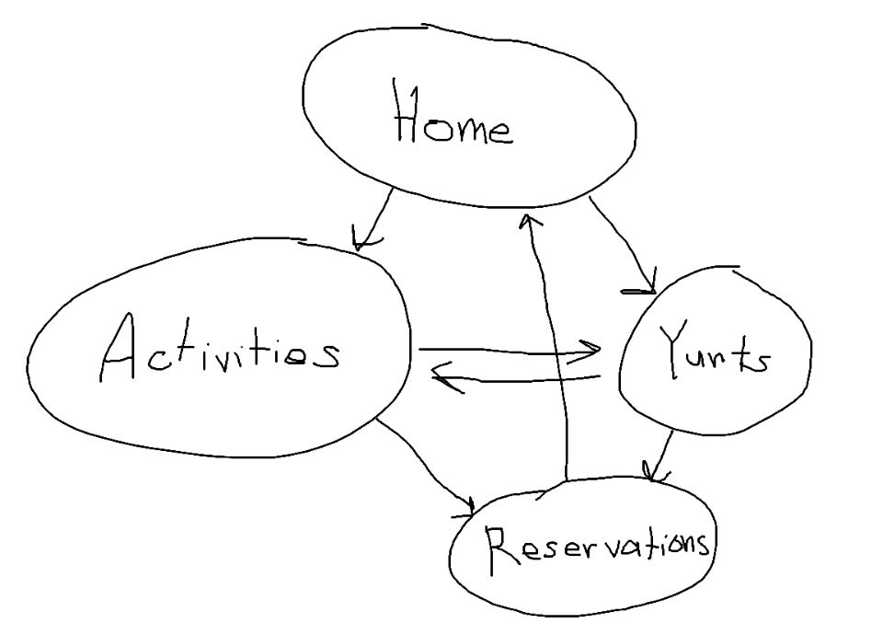
I think that the hierarchical organization structure is the best for the page, due to the freedom it gives to the users to navigate to wherever they want, but if I had to change it, I’d pick random over linear. People will always want to start with the home page, but the random structure lets them pick whether they would prefer to check out the yurts or the activities next. If they’re so wowed by that page, they can immediately go to reservations, but otherwise, they can check out the other page and then go to reservations. Once they’re done making a reservation, they can go back to the home page or leave the site.
On the other hand, a linear structure means I have to choose for the user whether they’re going to see the activities or yurts first after the home page, and then force them to see the other one, even if they wanted to skip the other page and go straight to reservations.

